3.1-2(c,d,e)

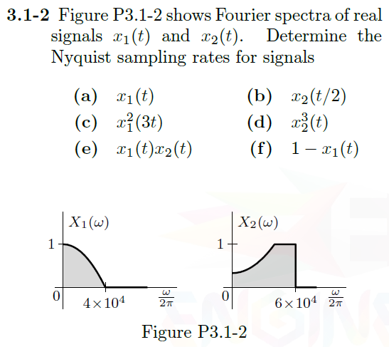

c) $x_{1}\left(3t\right)x_{1}\left(3t\right)$





$$x\left(3t\right)→\frac{X\left(\frac{ω}{3}\right)}{3}$$

This will cause max frequency in Fourier spectra to shrink from 40,000Hz to 13,333Hz

$$x\left(3t\right)x\left(3t\right)=X\left(ω\right)*X(ω)$$

Multiplication in time domain leads to convolution in frequency domain. According to width property:



So, Max Frequency in Fourier spectra will be 13,333Hz + 13,333Hz = 26,666Hz

Nyquist’s says that:

$$f_{s}≥2f$$

So,

$$f_{s}≥26,666*2=53,333Hz$$

d)   
As in problem c, this is equivalent to:



$$x_{2}^{3}\left(t\right)=x_{2}\left(t\right)x_{2}\left(t\right)x_{2}\left(t\right)$$

Multiplication in time-domain leads to convolution in the frequency domain.

According to width property:



So, new Fourier spectra max = (60,000Hz + 60,000Hz) + 60,000Hz = 180,000Hz

Nyquist’s says that:

$$f_{s}≥2f$$

So,

$$f_{s}≥180,000*2=360,000Hz$$

e)



Multiplication in time-domain leads to convolution in the frequency domain.

According to width property:



So, new Fourier spectra max = 40,000Hz + 60,000Hz = 100,000Hz

Nyquist’s says that:

$$f_{s}≥2f$$

So,

$$f_{s}≥100,000*2=200,000Hz$$

3.1-3(a,c)

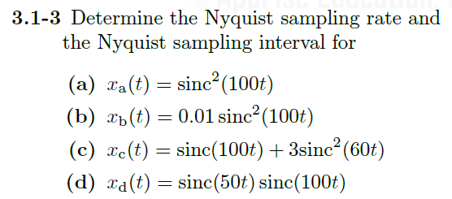

a) We know the Transform Pair for this function is:





Where, $B=200π$ and the Unit Triangle function is described as:

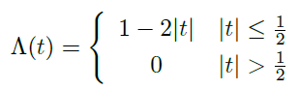

Then we can easily see that $x_{a}\left(t\right)$ will be zero when $ω=200π \frac{rad}{sec}$

Nyquist’s says that: $f_{s}≥2f$

So, $f_{s}≥100*2=200Hz$

And, $T_{s}≤0.005s$

c) Let’s say that: $x_{c,1}\left(t\right)=sinc\left(100t\right) and x_{c,2}\left(t\right)=3sinc^{2}(60t)$

We know the Transform Pairs for these two added functions are:







Then we can see that: $Max\left(X_{c,1}\left(ω\right)\right)=100π \frac{rad}{sec} and Max\left(X_{c,2}\left(ω\right)\right)=120π \frac{rad}{sec}$

Nyquist’s says that: $f_{s}≥2f$

So, $f_{s}≥60*2=120Hz$

And, $T_{s}≤0.0083s$